**Task 1- Create a Spring Web Project using Maven**

1. **Project Structure**

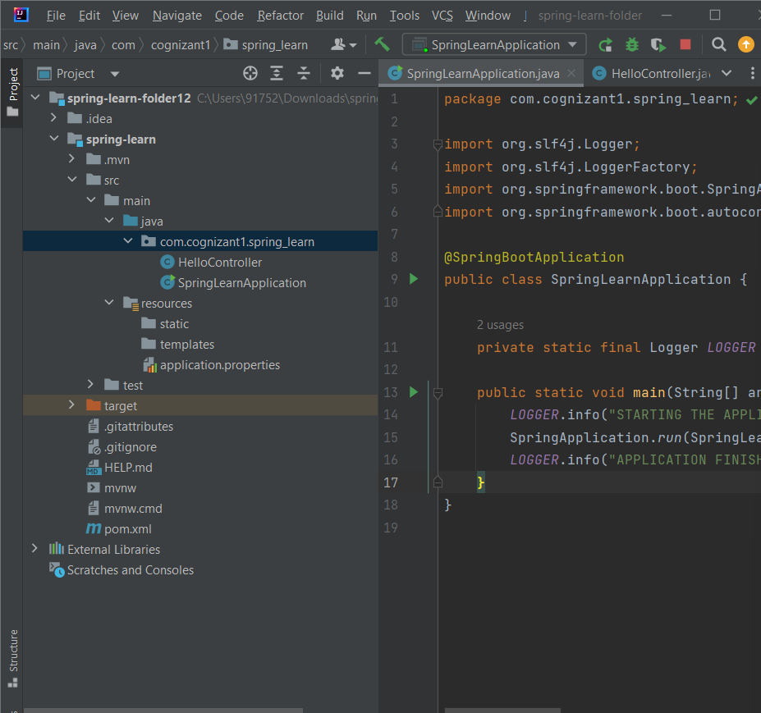

2-SpringLearnApplication.java

package com.cognizant1.spring_learn;  
  
import org.slf4j.Logger;  
import org.slf4j.LoggerFactory;  
import org.springframework.boot.SpringApplication;  
import org.springframework.boot.autoconfigure.SpringBootApplication;  
  
@SpringBootApplication  
public class SpringLearnApplication {  
  
 private static final Logger *LOGGER* = LoggerFactory.*getLogger*(SpringLearnApplication.class);  
  
 public static void main(String[] args) {  
 *LOGGER*.info("STARTING THE APPLICATION");  
 SpringApplication.*run*(SpringLearnApplication.class, args);  
 *LOGGER*.info("APPLICATION FINISHED");  
 }  
}

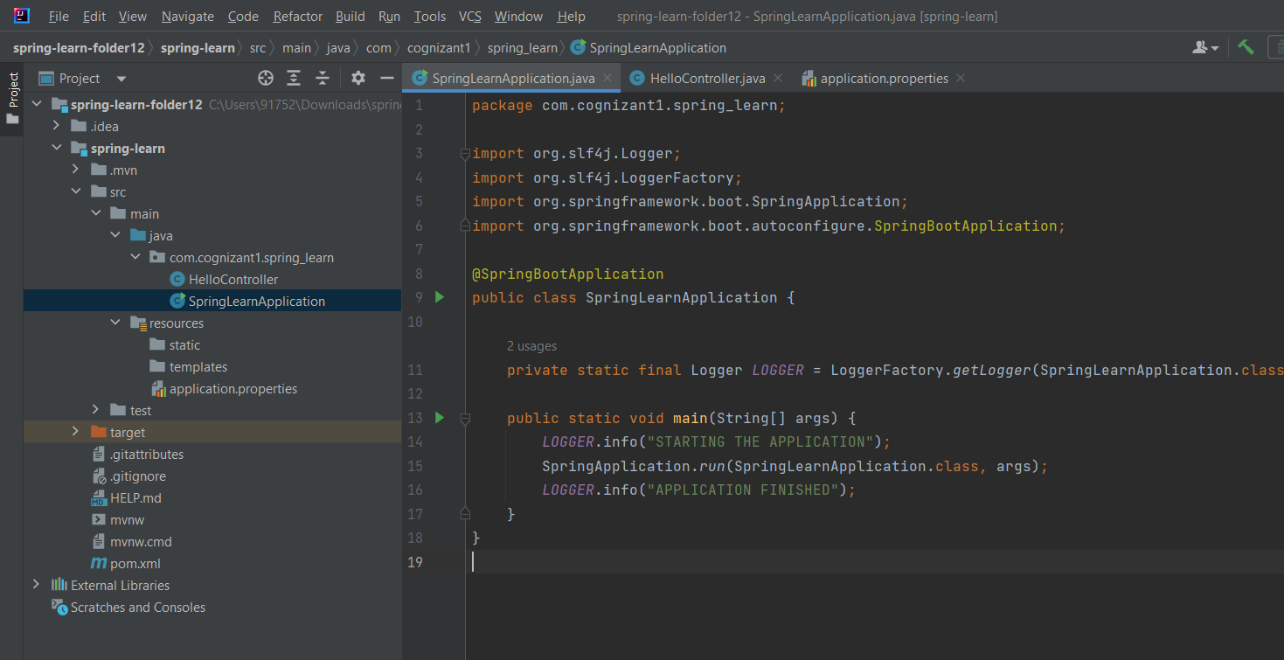

3-HelloController.java

package com.cognizant1.spring_learn;  
  
  
  
import org.springframework.web.bind.annotation.GetMapping;  
import org.springframework.web.bind.annotation.RestController;  
  
@RestController  
public class HelloController {  
  
 @GetMapping("/hello")  
 public String sayHello() {  
 return "Hello, Sanskriti! 🎉 Spring Boot is working!";  
 }  
}

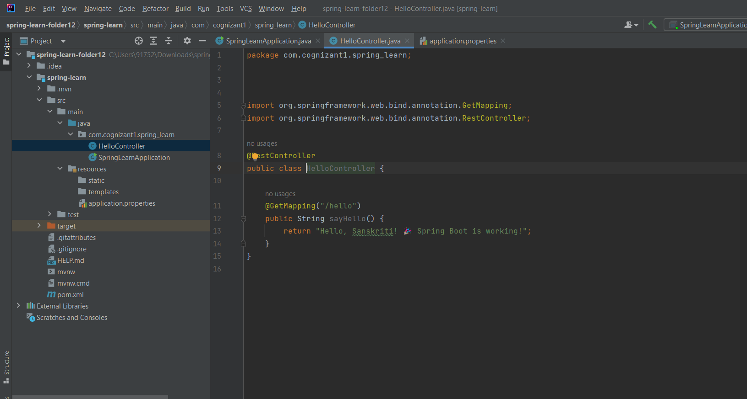

4- Output

